Report on Service and Repair of Network Devices and Racks in the Store (Equipment Room) at Nextmedia Services

Introduction

The efficient operation of network devices and racks is essential for maintaining the IT infrastructure at Nextmedia Services. This report outlines the procedures, common issues, and best practices for servicing and repairing network devices and racks in the Store (Equipment Room).

Common Issues

*1. Hardware Failures:*

- *Switches and Routers*: Failures due to overheating, power surges, or component wear.

- *Servers and Storage Devices*: Hard drive failures, memory issues, and power supply problems.

- *Cabling Issues*: Damaged or poorly connected cables causing connectivity problems.

*2. Environmental Issues:*

- *Temperature Control*: Overheating due to inadequate cooling or airflow.

- *Dust Accumulation*: Dust buildup causing overheating and component failures.

- *Humidity*: High humidity levels leading to corrosion and short circuits.

*3. Configuration Problems:*

- *Firmware/Software Updates*: Outdated firmware or software leading to security vulnerabilities and compatibility issues.

- *Network Configuration*: Misconfigured devices leading to network outages or performance degradation.

Procedures

*1. Diagnostic Testing:*

- *Hardware Diagnostics*: Use diagnostic tools to test the health of switches, routers, servers, and storage devices. Tools like SMART for hard drives and manufacturer-specific diagnostics for network devices.

- *Network Testing*: Use network monitoring tools to check for latency, packet loss, and connectivity issues.

*2. Environmental Control:*

- *Temperature and Humidity Monitoring*: Use sensors to monitor temperature and humidity levels. Ensure the equipment room is maintained within optimal environmental conditions.

- *Regular Cleaning*: Schedule regular cleaning to remove dust and ensure adequate airflow around network devices.

*3. Configuration and Updates:*

- *Firmware Updates*: Regularly update the firmware of all network devices to the latest versions provided by the manufacturers.

- *Configuration Audits*: Conduct periodic audits of device configurations to ensure they are set up correctly and optimally.

*4. Physical Inspection:*

- *Cable Management*: Regularly inspect and manage cables to prevent damage and ensure proper connections.

- *Rack Organization*: Ensure devices are securely mounted and organized within the racks to optimize space and airflow.

HERE THE MAINTENANCE WAS TAKING PLACE

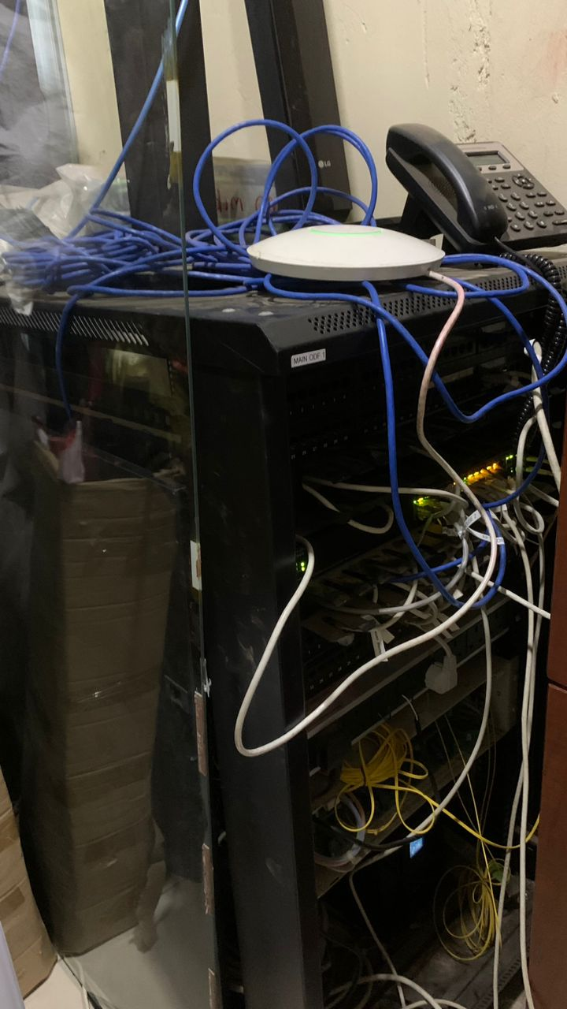 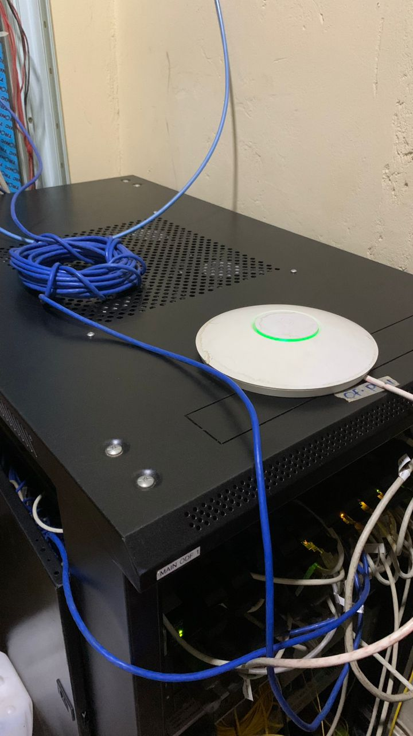

**AFTER**

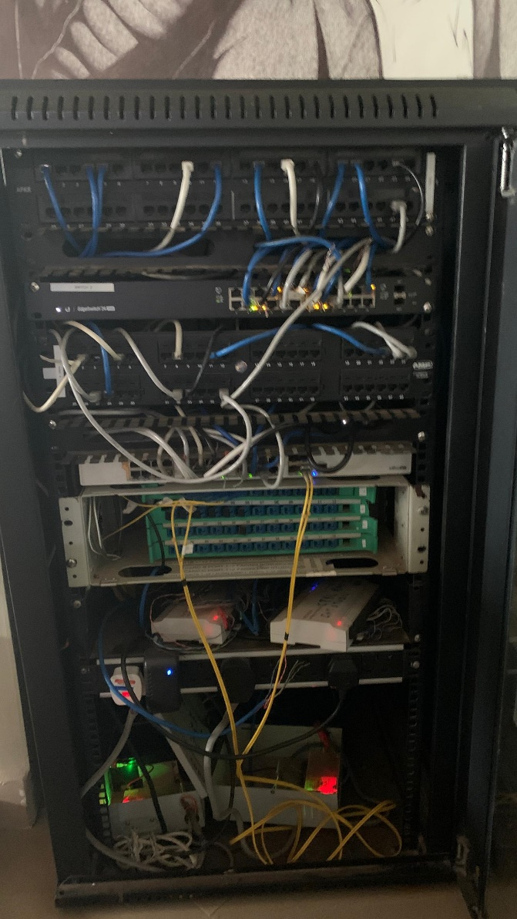

Best Practices

*1. Regular Maintenance:*

- *Scheduled Maintenance*: Perform regular maintenance checks, including hardware diagnostics, firmware updates, and physical inspections.

- *Preventive Measures*: Implement preventive measures like surge protectors and UPS systems to protect against power surges and outages.

*2. Documentation:*

- *Detailed Records*: Maintain detailed records of all devices, including configurations, firmware versions, maintenance activities, and any changes made.

- *Change Management*: Use a change management process to document and approve any changes to the network setup.

*3. Security Measures:*

- *Access Control*: Restrict physical access to the equipment room to authorized personnel only.

- *Network Security*: Implement robust network security measures, including firewalls, intrusion detection systems, and regular security audits.

*4. Environmental Controls:*

- *Optimal Conditions*: Maintain optimal temperature and humidity levels in the equipment room to prevent overheating and moisture-related issues.

- *Airflow Management*: Ensure proper airflow within racks and around devices to prevent hotspots.

*5. Training and Awareness:*

- *Staff Training*: Provide regular training for IT staff on best practices for maintaining and servicing network devices and racks.

- *Awareness Programs*: Conduct awareness programs on the importance of proper network maintenance and environmental control.

Conclusion

The service and repair of network devices and racks in the Store (Equipment Room) at Nextmedia Services are crucial for maintaining a reliable and efficient IT infrastructure. By following structured procedures and adhering to best practices, potential issues can be identified and resolved quickly, minimizing downtime and ensuring optimal performance. Regular maintenance, robust security measures, detailed documentation, and proper environmental controls are key components of a successful service and repair strategy.